GLOBAL EXECUTION CONTEXT (aniket mogare 24-09-2024)s

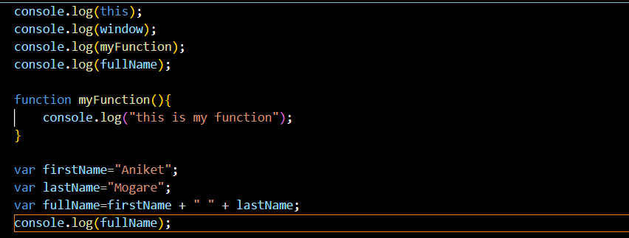

1)

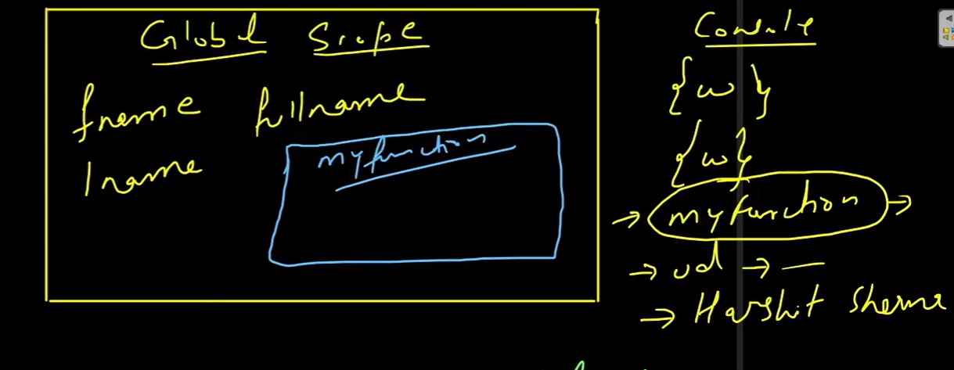

2) GLOBAL EXECUTION CONTEXT

CEP=CODE EXECUTION PHASE

